**Business Intelligence Project**

**Exploratory Data Analysis on Video Game Sales**

**Jainam Shah (18162121033)**

The dataset provided to perform exploratory data analysis on video game sales includes the following fields.

* Rank - Ranking of overall sales
* Name - The games name
* Platform - Platform of the games release (i.e. PC,PS4,DS etc.)
* Year - Year of the game's release
* Genre - Genre of the game
* Publisher - Publisher of the game
* NA_Sales - Sales in North America (in millions)
* EU_Sales - Sales in Europe (in millions)
* JP_Sales - Sales in Japan (in millions)
* Other_Sales - Sales in the rest of the world (in millions)
* Global_Sales - Total worldwide sales.

Exploratory Data Analysis on the given dataset has been performed using IBM COGNOS and graphics are displayed using DASHBOARD of COGNOS which gives precise insights on the game sales throughout the years and also provided various insights on most game genre preferred by users, most successful platforms and publishers, most played Games worldwide and longest running successful games.

**INSIGHTS**

1. **Overview**

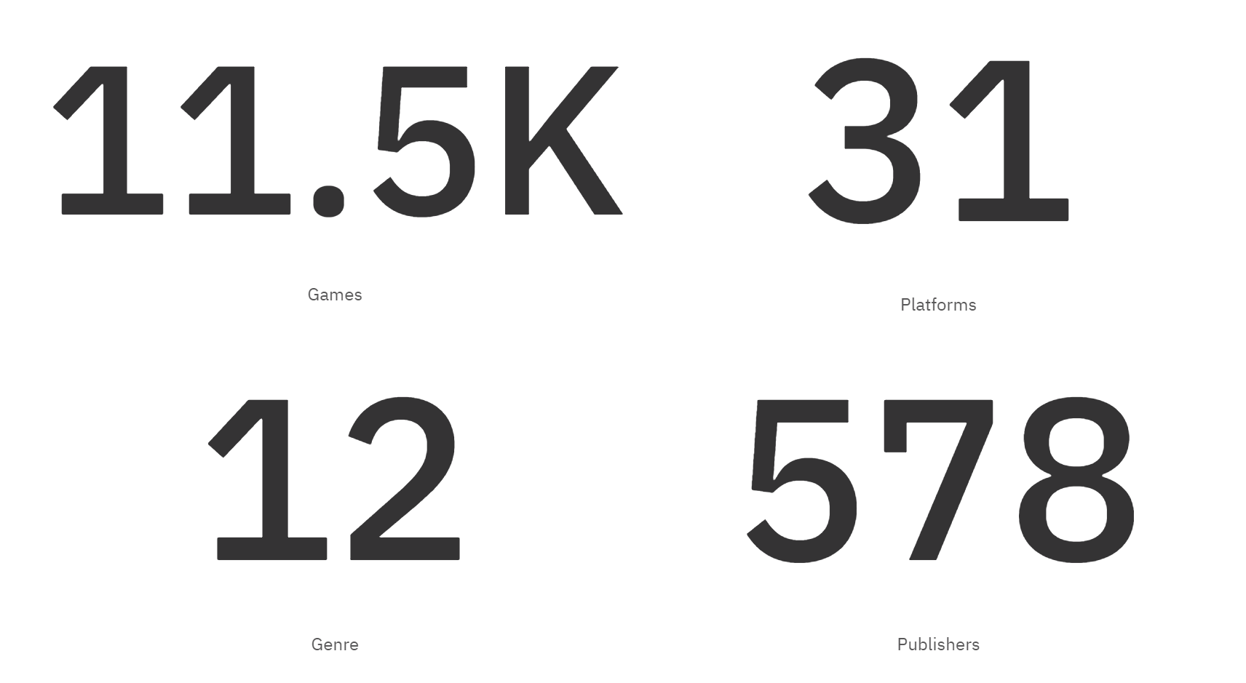

The above summary gives overview of the dataset which mentions there are around 11.5 thousand games on 31 different platforms of 12 different genre published by 578 different companies/publishers.

1. 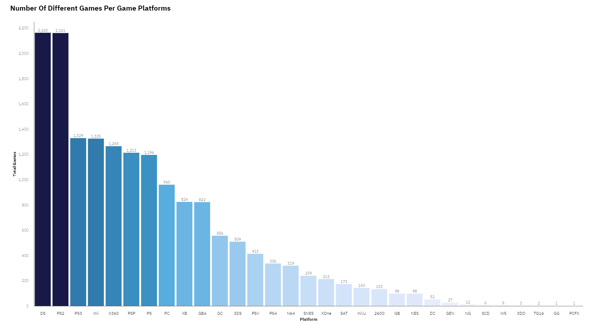**Game Platforms**

The above graph shows most used platforms for development of games i.e. DS and PS2 are the most used platforms by users and most games are developed on these 2 platforms. These 2 platforms are mostly preferred by users worldwide.

1. 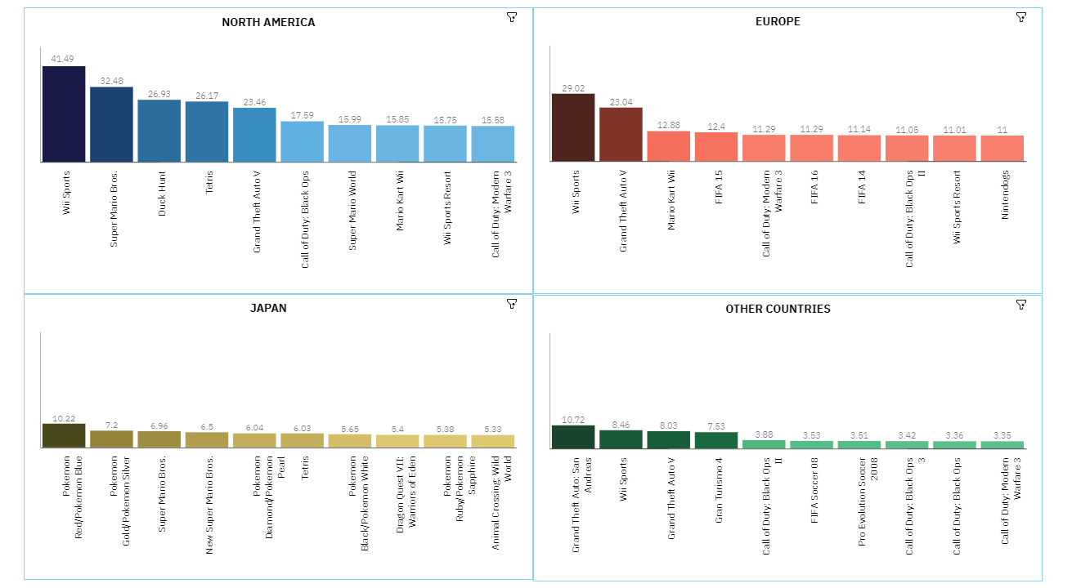**Games**

The above graphs show the TOP 10 games played in different regions. The regions are North America, Europe, Japan and Other countries. These TOP 10 games are chosen based on their sales in the respective regions.

**North America: -** The most played game in North America is Wii Sports which has around 41.49 million in sales.

**Europe: -** The most played game in Europe is Wii Sports which has around 29.02 million in sales.

**Japan: -** The most played game in North America is Pokémon Red/ Pokémon Blue which has around 10.22 million in sales.

**Other Countries: -** The most played game in North America is Grand Theft Auto San Andreas which has around 10.72 million in sales.

1. 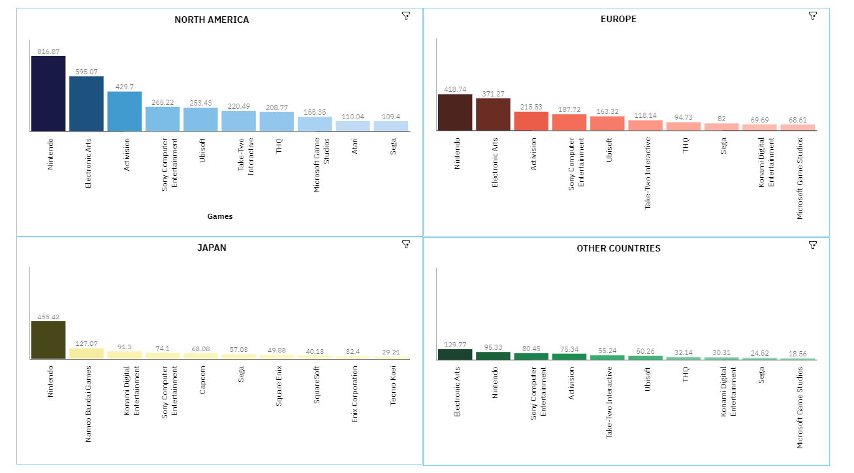**Publishers**

The above graphs show TOP 10 Publishers according to regions. These publishers have the highest sales in the respective regions. The regions are North America, Europe, Japan and Other Countries.

**North America: -** Nintendo is the Top publisher in North America with more than 816.87 million in sales throughout North America.

**Europe: -** Nintendo is the Top publisher in Europe with more than 418.74 million in sales throughout Europe.

**Japan: -** Nintendo is the Top publisher in Japan with more than 455.42 million in sales throughout Japan.

**Other Countries: -** Electronic Arts is the Top publisher in Other Countries with more than 816.87 million in sales throughout Other Countries.

1. 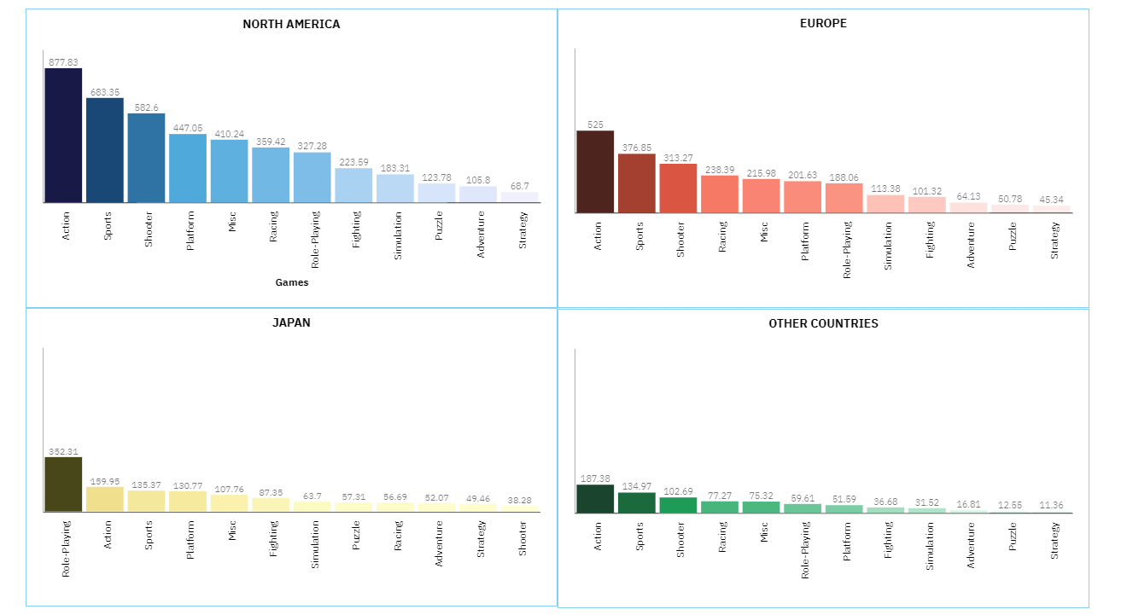**Genre (Region Wise)**

The above graphs show the most preferred genre by the users region wise. There are around 12 genres for respective games. The most preferred genre is sorted based on its sales in the respective regions. The regions are North America, Europe, Japan and Other Countries.

**North America: -** Action genre is the most preferred in North America as the games with genre as Action are sold most with around 877.83 million in sales in North America.

**Europe: -** Action genre is the most preferred in Europe as the games with genre as Action are sold most with around 525 million in sales in Europe.

**Japan: -** Role Playing genre is the most preferred in Japan as the games with genre as Role Playing are sold most with around 352.31 million in sales in Japan.

**Other Countries: -** Action genre is the most preferred in Other Countries as the games with genre as Action are sold most with around 187.28 million in sales in Other Countries.

1. 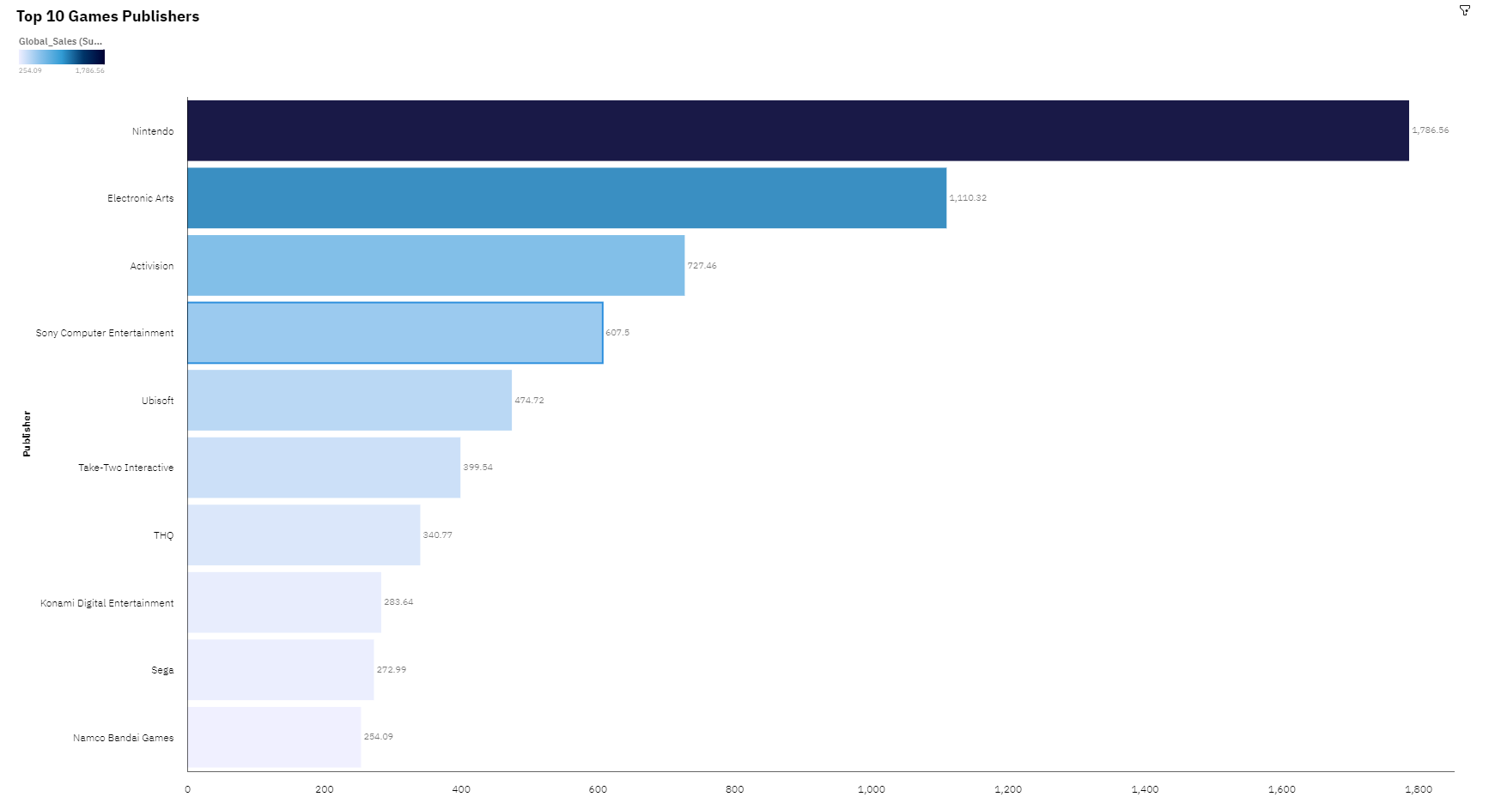**Publishers (Worldwide)**

The above graph shows the TOP 10 Publishers worldwide based on their sales. According to the Report Nintendo is the top publisher worldwide with around 1.7 billion in sales worldwide.

1. 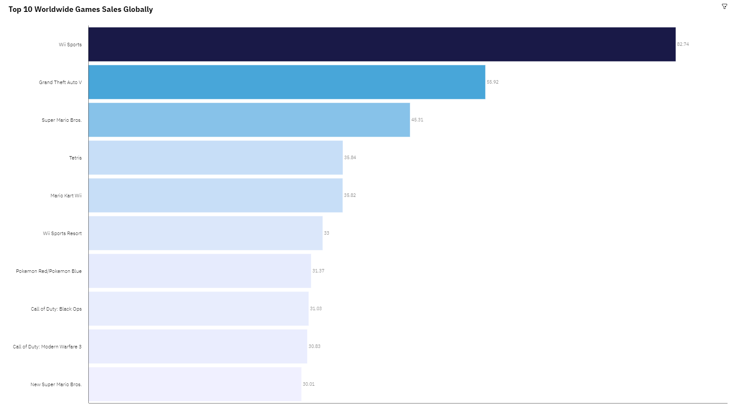 **Games (Worldwide)**

The above graph shows the TOP 10 Games which are played the most globally. These 10 games are the most played games by the users worldwide. The most played game worldwide is Wii Sports with more than 82.74 million in sales worldwide.

1. **Game Sales**

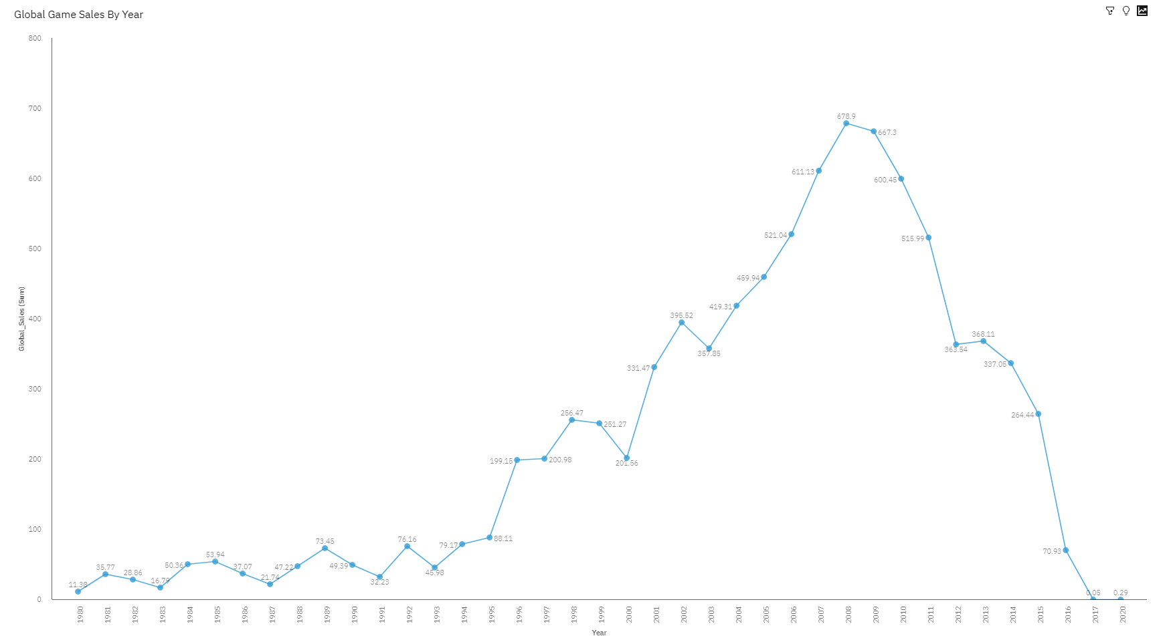

The above graph shows the games sales through the span of 40 years i.e. from 1980 to 2020. The year 2008 recorded the highest sales of games in the game making industry worldwide with around 679 million in sales throughout the whole year.

1. **Genre (Worldwide)**

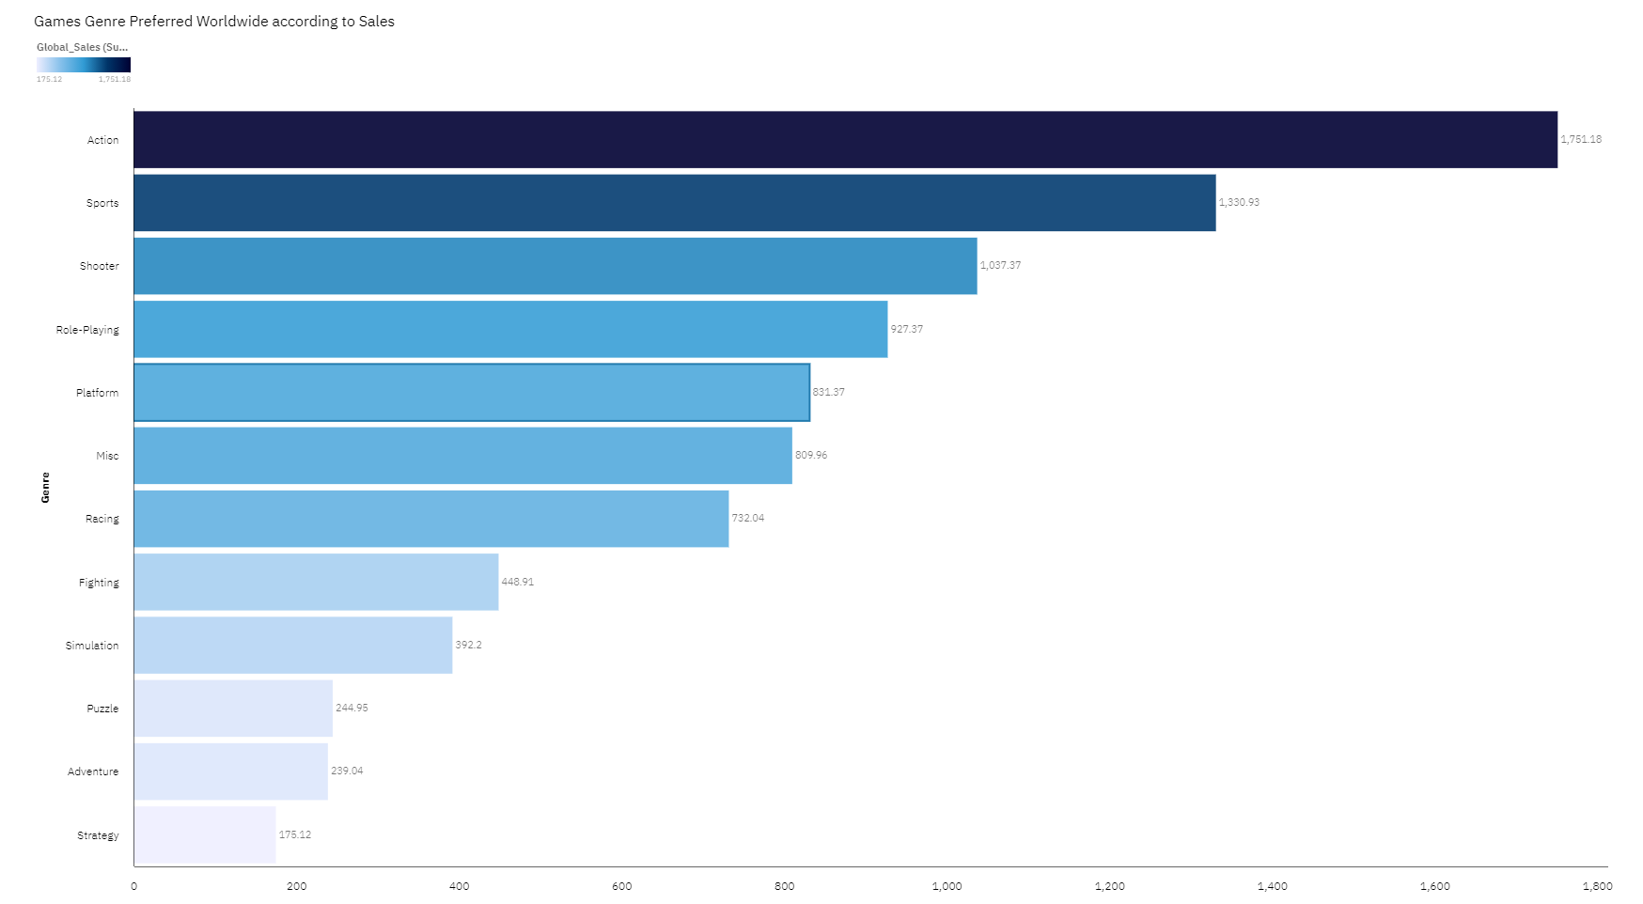

The above graph shows the most preferable genre by the users worldwide according to the sales of the respective genre. The Action genre in games is the most preferred by users which has around 1.7 billion in sales worldwide.

1. **Word Cloud**

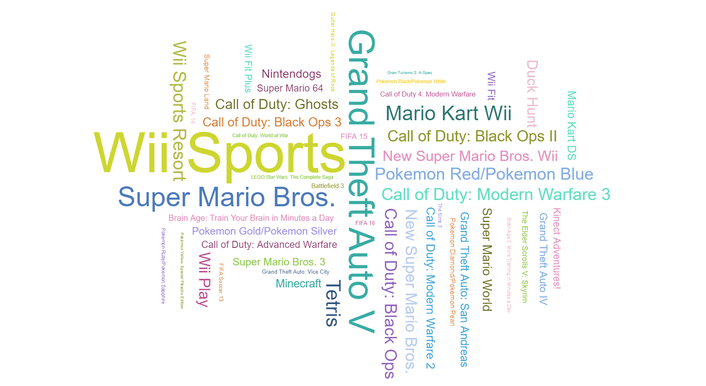

**Conclusion**

**Most Prominent Highlights**

* **Action** is the most played genre worldwide.
* **Nintendo** is the top publisher worldwide with around 1.7 billion dollars in sales.
* **DS** and **PS2** are the most preferred platforms by users and most games are developed for these two platforms.
* **Wii Sports** is the most played game globally.
* **North America** has the highest number of game sales each year, hence we can say that most users who play games are in North America.
* **Year 2008** has the highest game sales in the span of 40 years (1980-2020)**.**